SAFETY BAY
SENIOR HIGH SCHOOL

YEAR 10 EXAM SEMESTER1 2008

PLEASE DO NOT MARK THIS PAPER.

SECTION A: MULTIPLE CHOICE Answer all questions on the answer sheet provided by placing an X through the most correct answer.

1. The number of chromosomes found in a cell removed from the inside cheek of a woman would be:

a) 22 autosome pairs plus the XY sex chromosomes.
b) 22 sex chromosome pairs plus the XX autosomes.
c) 22 autosome pairs plus the XX sex chromosomes.
d) 22 sex chromosomes pairs plus the XY autosomes.

2. If a gorilla has 22 pairs of chromosomes in a skin cell, how many chromosomes are there in the gorilla's sperm?

a) 11 chromosomes.
b) 11 pairs of chromosomes.
c) 22 chromosomes.
d) 22 pairs of chromosomes.

3. When two individuals, both heterozygous for a single gene character, are crossed, all the
offspring happen to resemble their parents for that character. This genetic trait is
referred to as

- genotypic.
- dominant.
- phenotypic.
- recessive.

4. The name given to an individual in whom both genes for a characteristic are the same is

a) heterozygous.
b) homozygous.
c) monohybrid.
d) homologous.

5. Red-green colour-blindness is an X-linked recessive disorder. A mother with this condition and a normal visioned father will pass this allele to

- her daughters only.
- all of her children.
- her sons only.
- none of her children.

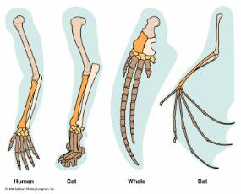

6. The image above illustrates:
a) vestigial structures.
b) homologous structures.
c) the fossil record.
d) natural selection.
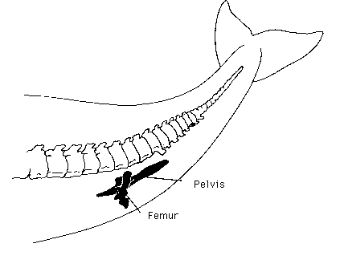

7. The image above illustrates which of the following?
a) Artificial selection.
b) Acquired characteristics.
c) Homologous structures.
d) Vestigial structures.

8. An allele is best defined as

- a lethal recessive phenotype
- a lethal dominant phenotype
- a type of gene found only on the sex chromosome
- an alternative form of gene at a given position on the chromosome.

9. If a woman with blood group AB marries a man with blood group O, what are the chances of the first child having blood group B?

- 0%
- 25%
- 50%
- 75%

10. The basic unit of inheritance is called a

a) zygote
b) DNA
c) chromosome
d) gene

11. Variation within a species refers to the

a) different traits exhibited by the members of a species.
b) changes that occur to the gene structure.
c) variety of family groups within the species.
d) natural selection processes that occur within plant and animal communities.

12. Albinism is inherited as an autosomal recessive trait. If a person has albinism and is married to a person who is heterozygous for the trait there is

- a 50% chance of having a child with albinism
- a 25% chance of having a child with albinism
- a 75% chance of having a child with albinism
- no chance of having an albino child

13. In humans, a male baby results when the

- egg is fertilised by a sperm carrying a Y chromosome
- egg is fertilised very early in the menstrual cycle
- unfertilised egg contains a Y chromosome
- woman’s vaginal fluid is very acidic (low pH).

14. Which of the following characteristics is controlled only by genes?
a) blood group.
b) intelligence.
c) ability to succeed at sport.
d) personality.

15. If a male parent has the genes TT and a female parent has the genes Tt:

a) all the offspring will be TT
b) some offspring will be tt
c) some sperm will have t genes
d) some eggs will have T genes

16. Chromosomes are present in

- all body cells.
- egg and sperm cells only.
- all cells.
- fertilised egg cells only.

17. There are many varieties of apple today, very different in flavour and size to the small
sour fruit of the wild apple. This is consistent with hypothesis that

a) artificial selection can change the characteristics of a population or species.
b) there has been an evolution from a species whose members were originally identical
in all respects.
c) evolution of the species depends on mutation.
d) each species had its own separate ancestors from the beginning of time.

18. Mary had black hair like her father but her mother has red hair. Mary is pregnant to Bill who has red hair. What is the probability that the child will have red hair? Assume hair colour is determined by a pair of genes at one locus, and that black hair is dominant to red.

a) 0.0
b) 0.25
c) 0.5
d) 1.0

Look at the diagrams and information below and then answer questions 19 – 22.

Insert diagram and questions cont drift

23. An atom consists of

a) a nucleus of protons and neutrons surrounded by electrons.
b) a nucleus containing neutrons surrounded by an electron cloud.
c) an electron cloud surrounded by protons and neutrons.
d) a nucleus of electrons and neutrons surrounded by a proton cloud.

24. In neutral atoms there are always equal numbers of

a) protons and neutrons.
b) protons and electrons.
c) neutrons, protons and electrons.
d) electrons and neutrons.

25. An atom has a mass number of 27.

a) 13 protons, 14 neutrons and 14 electrons.
b) 13 protons, 13 neutrons and 14 electrons.
c) 14 protons, 14 neutrons and 14 electrons.
d) 13 protons, 14 neutrons and 13 electrons.

26. What is the total number of atoms represented by the formula (NH₄)₃PO₄?

a) 20
b) 18
c) 17
d) 4

27. What is the difference between an element and a chemical compound?

a) A chemical compound is always more massive than an element
b) Only chemical compounds are normally found in nature
c) Only elements are normally found in nature
d) An element consists of only one type of atom

28. Which set below consists only of compounds?

a) Na, Ca, He
b) H₂S, CuCl₂, KI
c) NaCl, CH₄, Br
d) H₃O, Cl, I₃

29. Which of the following has an atomic number of 12 and has 2 electrons in its valence
shell?

a) Be
b) C
c) Na
d) Mg

30. In potassium fluoride, the potassium atom donates an electron and the fluorine atom
takes an electron. When the compound potassium fluoride is formed, which of the
following are formed?

a) covalent bonds
b) ionic bonds
c) magnetic forces
d) nuclear forces.

31. An ion can be best defined as

a) an atom which loses electrons.
b) an atom which gains electrons.
c) an atom which has a positive or negative charge.
d) a metal atom.

32. Which of the following elements is a noble gas?

a) Oxygen.
b) Chlorine.
c) Argon.
d) Nitrogen.

33. If you were looking for non metals on the periodic table, you would look

a) in the top rows.
b) in the middle.
c) on the left.
d) on the right.

34. Bonds that form between a metal and a non-metal are called

a) metallic bonds.
b) ionic bonds.
c) covalent bonds.
d) james bonds.

35. The atomic number of an element is the number of

a) neutrons in the nucleus.
b) protons in the nucleus.
c) electrons in the atom.
d) electrons and neutrons.

END OF MULTIPLE CHOICE

NAME………………………. TEACHER…………………….. .

SECTION B: SHORT ANSWER.

Answer the following questions in the spaces provided.

1. The diagram shows how two atoms of hydrogen are joined.

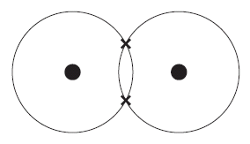

Complete the sentence using the following words.

a bond
an electron
a molecule
a nucleus

In the diagram, represents ………………………and X represents . . . . . . ………….
The two atoms are held together by . ……. …. . …. to form . . ………….. . . . of hydrogen.

(2 marks)

2. Write down the symbols for the following elements.

Gold……………….
Iodine……………..
Mercury…………..
Tin…………………
Oxygen…………..

(2 marks)

3. The balanced, symbol equation shows the atoms involved in a chemical reaction.

Fe₂O₃(s) + 3CO(g) 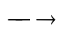 2Fe(s) + 3CO₂(g)
iron(III) oxide carbon monoxide iron carbon dioxide

Match words, A, B, C and D, with the numbers 1– 4 in the sentences.
NUMBER

A symbol ________

B compound ________

C atom ________

D element ________

O is the . . . 1 . . . for oxygen.
Fe₂O₃ is the formula for the . . . 2 . . . , iron oxide.
Fe represents one . . . 3 . . . of iron.
Carbon is a soft, black, non-metallic . . . 4 . . . .

(2 marks)

4. Give the chemical formula for the following compounds.

(a) calcium carbonate……………………………

(b) potassium phosphate………………………..

(c) sodium sulfite…………………………………

(d) aluminium oxide………………………………

(e) barium hydroxide…………………………….. (5 marks)

5. Outline three differences between mitosis and meiosis in the table below.

Mitosis | Meiosis
(6 marks)

6. Complete the table below.

For each of the statements below give a key word that Statement | Key word
A type of cell division producing gametes

A grid diagram used to predict types of offspring

When two alleles for a characteristic are the same.
An alternative form of a gene

(4 marks)

7. Consider the following pedigree for coat colour in mice. Mice can have black coats or
brown coats. Brown is the recessive gene.

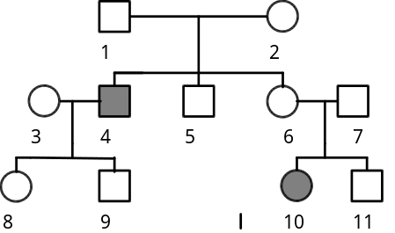

a) Which individuals have brown coats?______________ (1 mark)

b) What is the genotype for brown coats?_____________ (1 mark)

c) What would be the genotype of individual 1 and 2? Show your working.

(3 marks)

d) State the genotype for Pure bred black __________ (1 mark)

e) State the genotype for heterozygous black________ (1 mark)

f) Why are there 2 possible genotypes for black mice, but only one genotype for brown mice?

_________________________________________________________________________

________________________________________________________________________

_________________________________________________________________________

_________________________________________________________________________

(2 marks)

8. Red snapdragons are incompletely dominant to white snapdragons. All flowers produced from a cross between the two are pink.

(a) What would be the expected phenotypes of a cross between a pink and white snapdragon? Show your working.

(3 marks)

(b) What proportion of flowers produced from the cross in (a) would be red? Justify your answer.

(2 marks)

9. Tongue rolling is dominant to non-tongue rolling. A man who can roll his tongue, has
children with a woman who can also roll her tongue. They produce two children who
cannot roll their tongue.

(a) What is the chance that they produce a child who can roll their tongue? Show your working.

(3 marks)

(b) If they were to have another child, what is the chance they have boy who cannot roll his tongue? Show your working

(2 marks)

10. Haemophilia is an example of a sex-linked recessive characteristic. A person with haemophilia has blood that does not clot properly.

a) What is the genotype of a male who is haemophilic? ______

b) What are the genotypes of a female who is normal for blood clotting?

_____________________
(2 marks)

c) Show the possible genotypes and phenotypes resulting from a cross between a normal
male and normal (but carrier) female.

(5 marks)

11. Red-green colour blindness is a known sex-linked recessive characteristic; explain why
a male cannot be a carrier of the recessive allele for red-green colour blindness.

_________________________________________________________________

_________________________________________________________________

_________________________________________________________________

_________________________________________________________________

(2 marks)

END OF SHORT ANSWER
CHECK YOUR WORK CAREFULLY

VALENCE TABLE AND WORKING OUT SPACE.

